
Dashboard Design

Date | 29 October 2026
Team ID | [Enter Team ID]
Project Name | Electric Vehicle Market Performance & Insights
Maximum Marks | 5 Marks

Creating an effective dashboard involves thoughtful design to ensure that the presented information is clear, relevant, and easily understandable for the intended audience. Here are some key principles and best practices for dashboard design
Activity 1: Interactive and visually appealing dashboards
Creating interactive and visually appealing dashboards involves a combination of thoughtful design, effective use of visual elements, and the incorporation of interactive features. Here are some tips to help you design dashboards that are both visually appealing and engaging for users so take care of below points
- Clear and Intuitive Layout – Title at top; KPI Summary and category/manufacturer charts in the first row; battery, range, heatmap and trend charts below; filters and legends in a right-hand panel.
- Use Appropriate Visualizations – Bars for ranking (category sales, Top-10 manufacturers, range), pie for battery share, line for model-year trend, heatmap for rating by category × battery, map for countries, text for KPIs.
- Colour and Theming – One consistent Tableau 10 palette for battery type (LFP blue, NCA orange, NMC red, Sodium-Ion teal, Solid-State green) and a blue-teal sequential scale for ratings.
- Interactive Filters and Slicers – ‘% of Total Annual Sales’ range slider (9.82%–10.72%) and Battery Type filter/legend apply across sheets; legends highlight matching marks.
- Drill-Down Capabilities – Tooltips show exact values; clicking a battery type or category highlights it on every sheet; story points drill from overview into battery, geography and satisfaction detail.
- Responsive Design – Tiled containers with automatic sizing; dashboard embedded in a responsive Flask page; story view works in desktop and mobile browsers.
- Custom Visuals and Icons – Heatmap colour encoding, labelled percentage marks on pie and Top-10 bars, sorted bars.
- Use of Infographics – KPI Summary card (1.55 B units, 4.09 rating, 324.5 km) and percentage labels make the key numbers instantly readable.

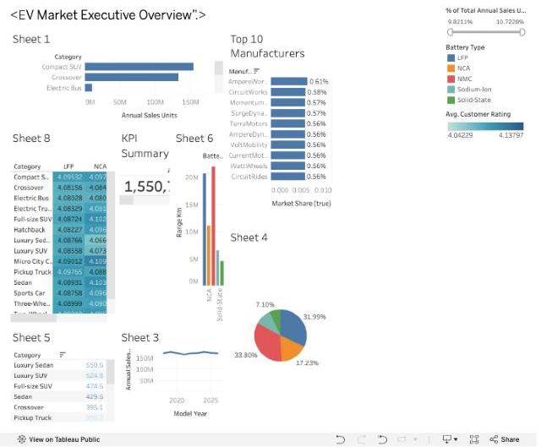
Figure: ‘EV Market Executive Overview’ dashboard (Tableau Public, Story point 1)
Note: Highlight the major outcomes in form of bullet points
Major outcomes:
Key outcomes from the EV Market Executive Overview dashboard:
- Market size: The KPI Summary reports 1,550,703,961 annual sales units from 200,000 EV models, an average customer rating of 4.09/5 and an average range of 324.5 km.
- Top categories: Two-Wheeler Scooters lead sales (174.6 M units, 11.3%), followed by Hatchback (154.9 M), Compact SUV and Sedan (153.4 M each); commercial trucks, pickups and buses are each below 1%.
- Fragmented manufacturer landscape: AmpereWorks leads with only 0.61% market share; the Top 10 of 200 manufacturers hold just 5.7% combined.
- Battery technology: NMC (33.8%) and LFP (32.0%) dominate; NCA holds 17.2% while Sodium-Ion (9.9%) and Solid-State (7.1%) are emerging. NMC and LFP also account for the highest total range (21.9 M and 20.8 M km).
- Range and satisfaction: Luxury Sedans (550.6 km) and Luxury SUVs (524.8 km) offer the longest range; ratings are uniformly good (4.04–4.14), highest for Electric Bus with Solid-State batteries. Sales stay stable at ~166–177 M units per model year (2018–2026).

Activity 2
Publish Dashboard on Tableau Public and Paste the Dashboard Public link below:
Dashboard Public link (dashboard is Story point 1 of the published workbook):
https://public.tableau.com/app/profile/rajlaxmi.pandey/viz/Book2_17936085689820/Story1

